This section of the project examines the distribution of media coverage on selected topics related to the Gaza conflict (2023–2024) in the Al-Jazeera news corpus. The analysis investigates how media narratives shifted before and during the conflict by observing the frequency of selected topics such as casualties, media/journalists, diplomatic resolutions, human rights, and humanitarian crises.
The main argument I depicted from this analysis is that while there is an expected surge in reporting on immediate conflict casualties when the war breaks out, other essential dimensions of the conflict, particularly media transparency, diplomatic negotiations, human rights, and humanitarian aid receive inconsistent, comparatively low, or unstained attention. The data visualisation clearly reveals this imbalance, offering insights into how conflict narratives are constructed and prioritized by media outlets in crisis settings.
The analysis consisted of two Python scripts:
Data Preparation and Merging Script:
The first script loaded two datasets — one containing topic modelling results (topic-model.csv) and the other containing article length information (length.csv). These were merged using an inner join on the common date columns ['year', 'month', 'day']. Rows with a Topic ID of -1 were filtered out, as they indicated unclassified or irrelevant content. A mapping of Topic IDs to descriptive names was created by concatenating the top three keywords associated with each topic, making them human-interpretable for visualization.
To narrow the focus, the data was filtered for the years 2023 and 2024, and five specific topics were selected based on their relevance to the Gaza conflict. These topics included conflict casualties, journalists and media, diplomatic resolutions, human rights, and humanitarian aid. A new column, Year Month, was created by combining the year and month columns for chronological ordering. Topic occurrences were then counted for each month.

Visualization Script:
The second script used Plotly Express to create interactive visualisations: a grouped bar chart and a line graph. The bar graph plotted the number of articles per topic by month, while the line graph showed topic trends over time. I used Plotly Express for this visualization because it offers interactive and clear representations. We can see that, as expected, the topic “gaza, people, killed” had a huge spike in October and November 2023 when the war broke out. This sharp increase made sense as the initial news coverage focused heavily on casualties and violence.
However, if we look at other topics like “journalists, abc, media” or “rights, human, un”, their coverage remained quite low and inconsistent throughout the period. Logically, after covering the immediate conflict, media should have focused more on reporting conditions, diplomatic resolutions, and human rights issues — but these topics did not receive comparable attention, which shows a significant imbalance in media focus. Even the topic related to “aid, food, famine”, which highlights the humanitarian crisis, was also underreported, especially when compared to the casualty reports.
These visualizations aimed to explore patterns in how media attention shifted between different topics during the Gaza conflict.
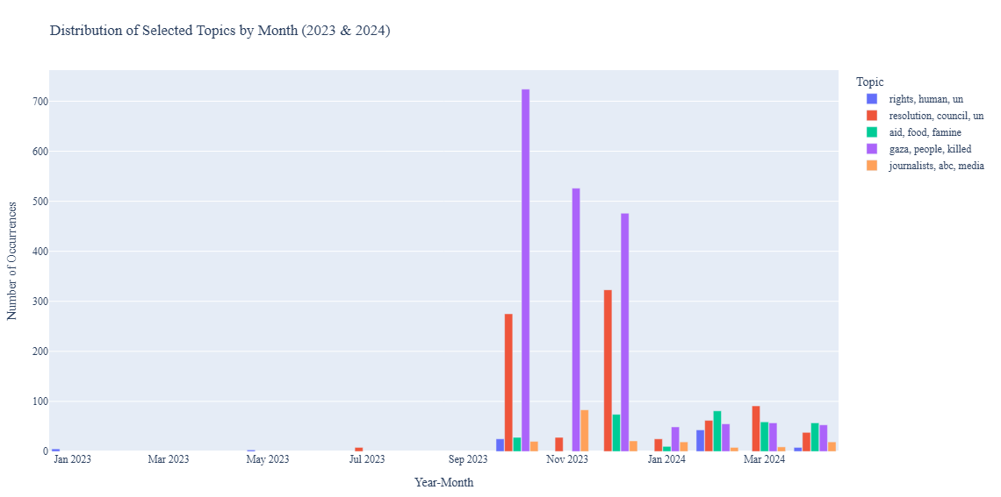
The second visualization was a line graph to show the trends of these selected topics over time. This graph helped to visualize the fluctuations and long-term trends. It clearly showed that while conflict-related topics dominated early in the conflict, there was no sustained increase in coverage of humanitarian or diplomatic topics in the months that followed. By March 2024, the topic “aid, food, famine” saw a slight increase but was still lower than expected given the scale of the humanitarian crisis. 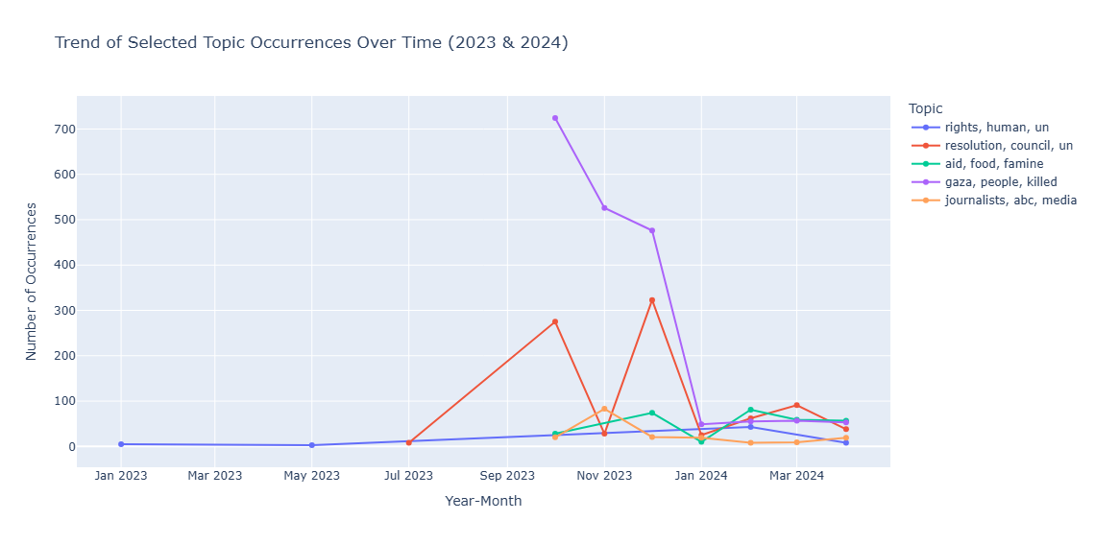
Conclusion:
In this part of the project, I noticed a clear imbalance in how Al-Jazeera covered the Gaza conflict. Most of the focus was on casualties when the war started, which made sense, but other important topics like journalists, human rights, and humanitarian aid didn’t get as much attention. Using topic modelling with article length data helped me track these patterns over time. While this method doesn’t show the exact context, it made it easy to see which topics were talked about most. It showed how media coverage can shape public understanding by focusing on some issues more than others.

